When you're ready, please provide for **"Framing Fundamentals"**:

**Program Structure:**

* **Week 1 & Week 2 focus areas**
* **3 sessions per week** (Session 1, 2, 3 for each week)

**For Each Session:**

* **Session title** (e.g., "Stance & Setup Fundamentals")
* **Duration** (e.g., 30-40 minutes)
* **Learning objectives** (what skills they'll develop)

**For Each Drill:**

* **Drill name** (e.g., "Basic Receiving Stance")
* **Duration** (e.g., 5 minutes)
* **Equipment needed** (e.g., "Glove, tennis balls")
* **Instructions** (step-by-step what to do)
* **Coaching points** (what to focus on)
* **Progression notes** (how it builds toward next drill)

WEEK 1: Introduction, Setups, Stances, Tennis Balls.

Session 1: Introduction to stances and setups

Duration: 30 minutes

Learning Objectives: Catcher will understand the three different stances, how differing scenarios affect their setup, and will learn how to digest game information and translate that into the setup they will use for each pitch.

* We have three options when it comes to a setup.
  + Traditional setup (both knees up, in a deep squat)
    - 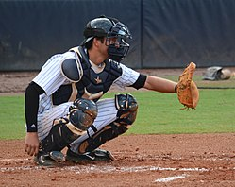
    - Insert video as well.
  + Left knee down setup
    - 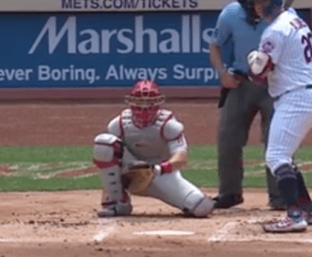
    - Insert video
  + Right knee down setup
    - 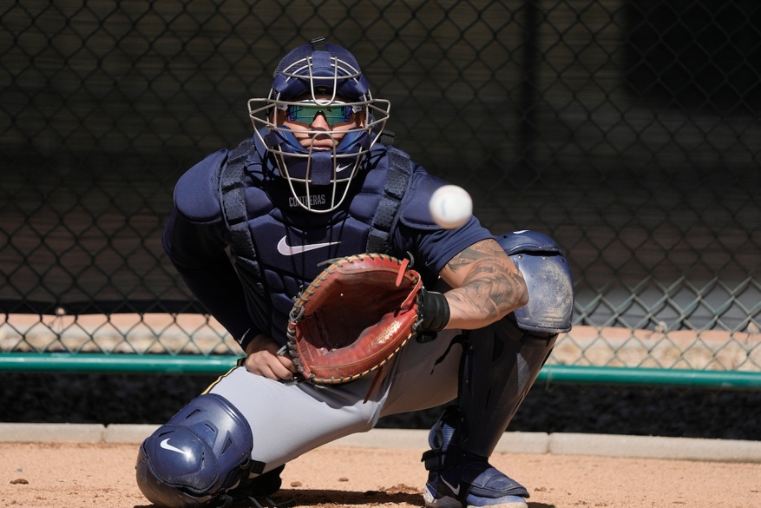
    - Insert video
* There are three scenarios that will dictate our setups and stances.
  + Number 1: Nobody on base, less than 2 strikes.
    - In this stance, the only focus of the catcher is framing. There are no other pressing matters, such as the need to block or throw.
    - When deciding which setup to employ, there are a few factors to think about.
      * What is the count?
        + Early in the count, or when we need to prioritize getting a strike (0-0, 0-1, 1-1, 2-1,3-1, 3-2) most of the time we want to set up more in the middle of the plate to give our pitcher the best target to be in the strike zone.
        + Later in the count (0-2, 1-2, 2-2), when our focus now shifts more towards striking the batter out, we can venture more towards the corners of the plate to help our pitcher throw pitches more on the corners or to hopefully get the batter to chase a pitch outside of the strike zone.
      * What pitch are you calling?
        + If you are calling a breaking ball from a Right-Handed Pitcher, we should anticipate where most of the pitches will be. The pitch is moving to our right, so we want to get in the setup that gives up the best chance to present the ball to the umpire.
        + If we are calling a sinker, that ball is going to be moving to our left. We want our setup to help us receive this pitch as best as possible, which may include an angle back towards the plate with our setup.
        + We should always be anticipating how the pitch will move, the location in which we are expecting it. The pitch will not always be where we expect it, but we want to anticipate and then adjust.
    - Test out all three setups (Traditional, right knee down, left knee down) and see which is most comfortable for you to receive pitches in all different parts of the zone. This varies greatly from catcher to catcher, and there is no right way to do this!
  + Number 2: Nobody on base, 2 strikes
    - In this scenario, we have two factors to address. We want to frame pitches as well as we can, but we also must able to block pitches in the dirt, because if the batter swings at a ball in the dirt, he can run to first base on a dropped third strike, and we must control the ball and throw him out at first base.
    - Test out all three stances and imagine yourself anticipating framing a strike, while reacting to a ball in the dirt to block. Which stance feels the best to you?
  + Number 3: Runner on base.
    - In this scenario, we have three factors to address. Framing, blocking (to prevent runner from advancing on a ball in the dirt), and throwing if a runner attempts to steal a base.
    - Go through all the setups, and see which setup makes you feel the most athletic and gives you the best ability to frame, block, and throw from.
* **DRILL**: Random setups -
  + Now that we have addressed the different stances and scenarios, the first drill will be to go through different scenarios in your head, or have a coach call them out to you. Given the scenario (Count, runner on base, and what pitch), you will get into your setup.
  + Practice doing this for 20 repetitions, each time getting more comfortable selecting a setup to address the current scenario.
  + Equipment: None needed
    - Optional – helper calling out different scenarios
  + Focus on consistent setups. Each time you are using a certain setup, know your checkpoints

Session 2: Tennis Ball Receiving

**Session title** : Basic Tennis Ball Receiving

* **Duration**: 30 minutes
* **Learning objectives**: Catcher will learn how to catch and stick the ball.

**For Each Drill:**

* **Drill name** Two knees down tennis ball receiving
* **Duration**: 3 rounds of 20 repetitions
* **Equipment needed**: Tennis Balls. Coach/helper optional
* **Instructions**: Put both knees down on to the ground. Start with your bare hand on the ground. If you have a coach, have a coach flip you the ball and you are going to work up from the ground, catch the ball, and then stick it. Stick it means you will hold the ball there right after you catch it. If you do not have a coach, toss the ball off of a wall and receive it.
* **Coaching points**: Make only one move with your hand to the ball. When it comes off the ground, it is a quick and aggressive move to catch the ball. Try to eliminate as much body movement as possible.

Session 3: Setups and tennis ball receiving

**Session title** : Setups + Tennis ball receiving

* **Duration**: 30 minutes
* **Learning objectives**: Catcher will practice changing stances and then will receive tennis balls from various different setups.

**For Each Drill:**

* **Drill name**: Normal tennis ball receiving with variable setups.
* **Duration**: 3 rounds of 20 repetitions
* **Equipment needed**: Tennis Balls. Catchers Mitt. Coach/helper.
* **Instructions**: Coach/Helper will call out a scenario (i.e. runner on first, 2 strikes, Slider). Then the coach will throw the pitch and catcher will frame the pitch.
* **Coaching points**: Focus on consistent setups. Take that feeling of one move to the ball from the knees down receiving. Minimize movement of the body.

WEEK 2: Advanced receiving

Session 1: Coach Pitch Framing

**Session title** : Coach Pitch Framing

* **Duration**: 30 minutes
* **Learning objectives**: Catcher will catch real baseballs thrown by a coach. Moving towards game like pitching

**For Each Drill:**

* **Drill name** Coach Pitch Framing
* **Duration**: 3 rounds of 20 repetitions
* **Equipment needed**: Baseballs. Coach/helper, catchers mitt, catchers gear.
* **Instructions**: Choose a scenario, then use the corresponding setup. Stay here for a full round of 20 repetitions. Coach will throw pitches and catcher will frame pitches to the best of his ability. The variability of the live arm will replicate game-like variability.
* **Coaching points**: Make sure you get the glove load done early. Limit body movement as much as possible. One move from the ground to the ball.

Session 2: Long Slow Breaking Balls

**Session title** : Long Slow Breaking Balls

* **Duration**: 30 minutes
* **Learning objectives**: Catcher will learn how to wait and be patient while making the glove move as quick as possible.

**For Each Drill:**

* **Drill name** Long Slow Breaking Balls
* **Duration**: 3 rounds of 20 repetitions
* **Equipment needed**: Baseballs. Catchers mitt. Coach. Pitching machine optional.
* **Instructions**: Get in your most comfortable setup. If you have a machine, set up 60 feet from machine. Put the machine on slow curveballs landing right behind the plate. If you have a coach, have him throw really big slow curveballs landing right behind the plate. Do your glove load, but wait as long as you can. When you move to catch the ball, it should be a very short and quick move with no body movement.
* **Coaching points**: If you are having trouble waiting, put a cone 5 feet in front of you and don’t move until the ball gets to that cone.

Session 3: Velocity Framing

**Session title** : Velocity Framing

* **Duration**: 30 minutes
* **Learning objectives**: Get used to catching high velocities

**For Each Drill:**

* **Drill name**: Velocity Framing
* **Duration**: 3 rounds of 20 repetitions
* **Equipment needed**: Pitching Machine. Baseballs. Catchers Gear. Catchers glove. Coach
* **Instructions**: Get in any one of your stances. Set the machine to a hard fastball. Practice moving the pitch as quickly as you can while limiting body movement. Stick as best you can.
* **Coaching points**: If you are having success catching pitches at first, you can move closer to the machine to make it more challenging. Can also work sides of the plate if you are looking for more of a challenge.